FlowForge-BootStrap Setup

In this document we will go through the various steps to setup the entire application and the devsecops pipeline for the flowforge application in azure environment .
Github Repositories to Refernence:
https://github.com/Noel-Mathews-Org/FlowForge
https://github.com/Noel-Mathews-Org/FlowForge-Helm
https://github.com/Noel-Mathews-Org/FlowForge-Terraform

- Fork these 3 repo with both the dev and prod branch and I want you to create these :
- First Create a Organization and add go to Organization settings->secrets and variabales-> actions->:
SONAR_TOKEN – Sonar Cloud Access Token
SONAR_HOST_URL – Sonar Cloud URL
SNYK_TOKEN – SNYK Sca Scan Access Token
MAIL_USERNAME – SMPT Gmail Username – Used for sending alert in github
MAIL_PASSWORD – SMTP Gmail Password (App Password)
INFRACOST_API_KEY – Infracost api key
GH_PAT – Github Personal Access Token with Repo Scope
DEVELOPMENT_TEAM_EMAIL – Gmail to which you want to send the alerts to
AZURE_TENANT_ID – Azure Tenant ID
AZURE_SUBSCRIPTION_ID – Azure Subscription ID
AZURE_CLIENT_ID – Azure App Registration Application (Client) ID
AZURE_CI_CLIENT_ID – The Client ID of the Managed Identity for CI PIpelines
ACR_NAME – Azure Container Registry Name
ACR_LOGIN_SERVER – Azure Container Registry Login URL

- The values given in Red Colour will be made available after we run the Terraform Pipeline and in the outputs
After that we need to go into induvitual Repository:
- In Terraform Repo go to Repo Settings-> Enviornments-> Create New Enviornments and create 4 Enviornments
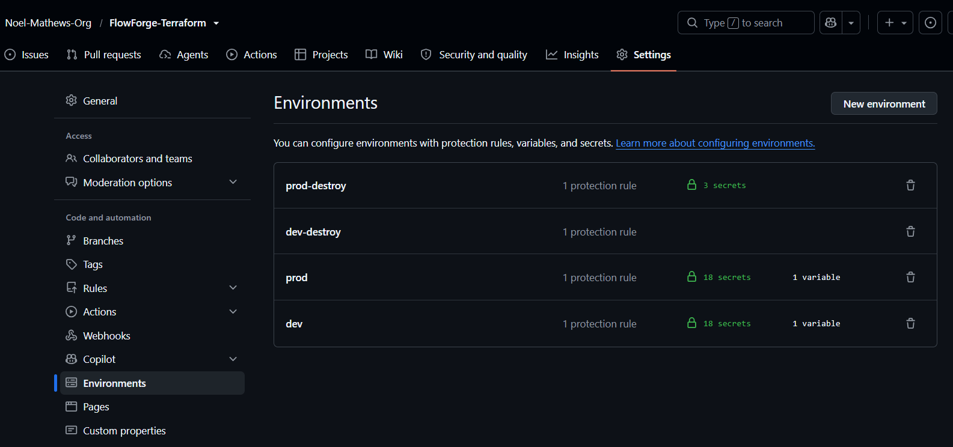

each environment should have deployment protection rules where it should have atleast 1 required Reviewers ,
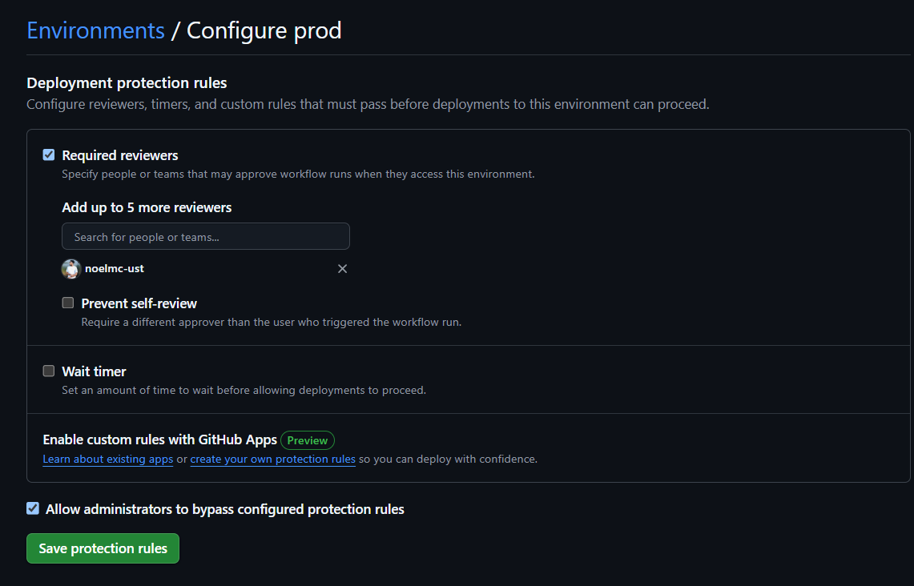
Now we need to add secrets for environments :
Open the Prod environment and add these values correctly:


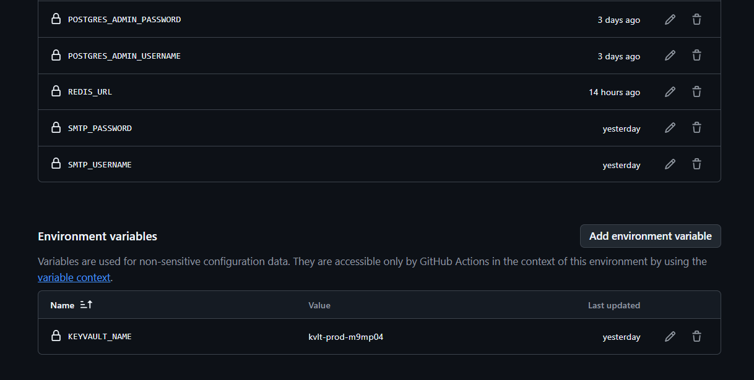

This ARC RUNNER CLIENT ID – Client ID of the Managed identity of ARC Runner we are going to setup inside the AKS
AZURE FOUNDRY ENDPOINT , DATABASE URL , REDIS URL will only be available only after our terraform pipeline runs

The remaining Secrets ;
ENTRA_TENANT_ID
ENTRA_CLIENT_ID
ENTRA_CLIENT_SECRET
ENTRA_GROUP_PLATFORM_ADMIN
ENTRA_GROUP_ORG_OWNER
ENTRA_GROUP_MANAGER
ENTRA_GROUP_MEMBER

We will show how to get these values in the remaining steps;
Rest secrets you can give you values as needed , add the same secrets for the dev environment also
For prod-destroy and dev-destroy
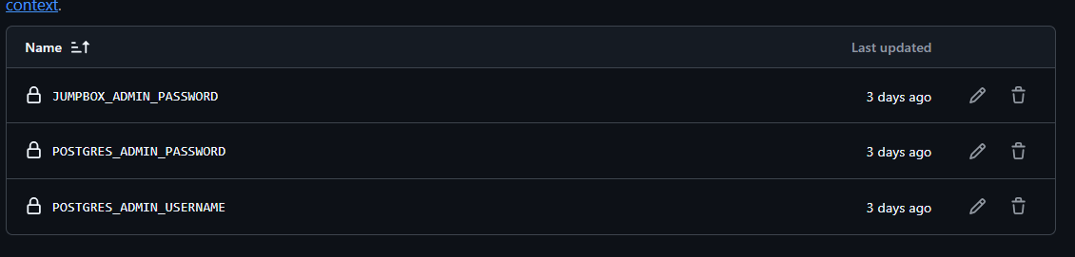

Add These values , because these are the values in 4 environments which are needed for our Terraform Pipeline to Run ,

For all the activity related to infrastructure we have 3 pipeline-
- gitops-terraform pipeline – used to setup the infrastructure in both dev and prod environments where we can select the env we want to setup and has manual deployment protection enabled and approval gates are present

- secrets needed for it to work:
AZURE_TENANT_ID – Organization secret
AZURE_SUBSCRIPTION_ID– Organization secret
AZURE_CLIENT_ID– Organization secret
POSTGRES_ADMIN_USERNAME- Environment Secret Prod/Dev
POSTGRES_ADMIN_PASSWORD- Environment Secret Prod/Dev
JUMPBOX_ADMIN_PASSWORD- Environment Secret Prod/Dev
INFRACOST_API_KEY– Organization secret
MAIL_USERNAME– Organization secret
MAIL_PASSWORD– Organization secret
DEVELOPMENT_TEAM_EMAIL– Organization secret

- terraform-destory pipeline – used to destroy terraform infrastructure in both dev and prod environments:
- secrets needed for it to work:
AZURE_TENANT_ID – Organization secret
AZURE_SUBSCRIPTION_ID– Organization secret
AZURE_CLIENT_ID– Organization secret
POSTGRES_ADMIN_USERNAME- Environment Secret Prod/Dev
POSTGRES_ADMIN_PASSWORD- Environment Secret Prod/Dev
JUMPBOX_ADMIN_PASSWORD- Environment Secret Prod/Dev
INFRACOST_API_KEY– Organization secret
MAIL_USERNAME– Organization secret
MAIL_PASSWORD– Organization secret
DEVELOPMENT_TEAM_EMAIL– Organization secret

- update-keyvault-secrets pipeline – used to update the secrets in our dev and prod keyvault using the self hosted runner we have setup usingAction Runner Controller in AKS, These are the secrets needed for our application run
- secrets needed for it to work:
DATABASE_URL – Environment Secret Dev/Prod
REDIS_URL – Environment Secret Dev/Prod
JWT_SECRET -Environment Secret Dev/Prod
INTERNAL_API_KEY -Environment Secret Dev/Prod
ENTRA_TENANT_ID -Environment Secret Dev/Prod
ENTRA_CLIENT_ID -Environment Secret Dev/Prod
ENTRA_CLIENT_SECRET -Environment Secret Dev/Prod
AZURE_FOUNDRY_KEY -Environment Secret Dev/Prod
AZURE_FOUNDRY_ENDPOINT - Environment Secret Dev/Prod
SMTP_USERNAME -Environment Secret Dev/Prod
SMTP_PASSWORD -Environment Secret Dev/Prod
ENTRA_GROUP_PLATFORM_ADMIN -Environment Secret Dev/Prod
ENTRA_GROUP_ORG_OWNER -Environment Secret Dev/Prod
ENTRA_GROUP_MANAGER -Environment Secret Dev/Prod
ENTRA_GROUP_MEMBER -Environment Secret Dev/Prod

- Github Environment Variable
KEYVAULT_NAME- Environment Dev/Prod

Make sure to setup branch protection rule for the main branch in 3 repository so we can control who all can push code
--------------------------------------------------------------------------------------------------------------

We will first start with what all to do in Azure Portal First:
- First go to Azure Portal -> Entra ID -> App Registration – New Registration

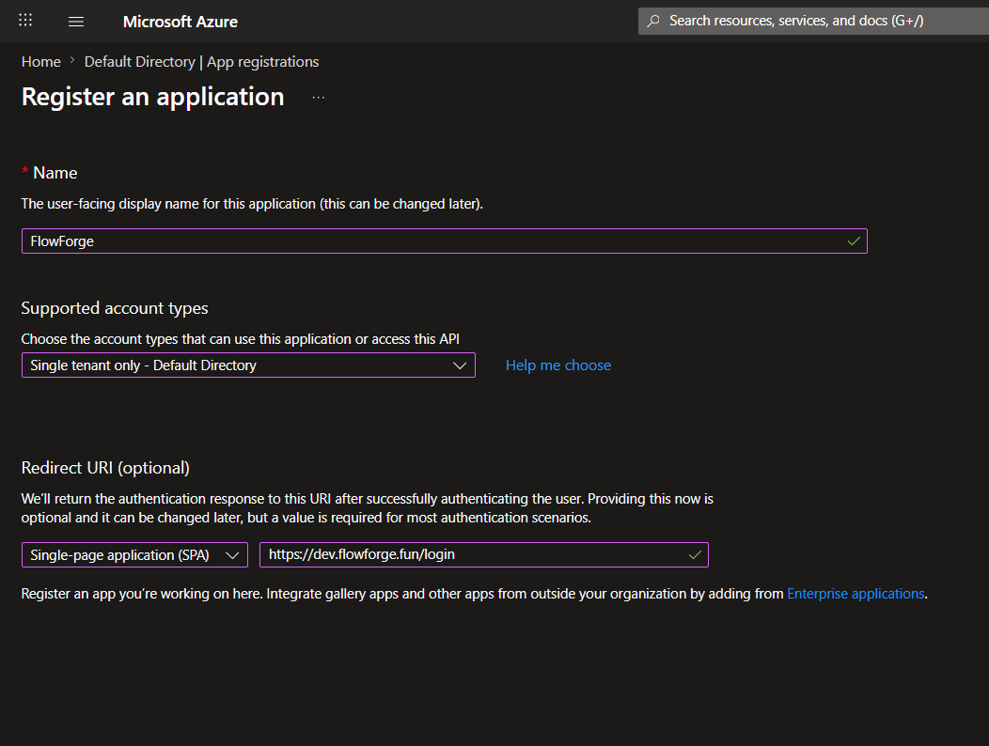
- Add details accordingly after creating the app registration open it and add other 3 redirect URLs

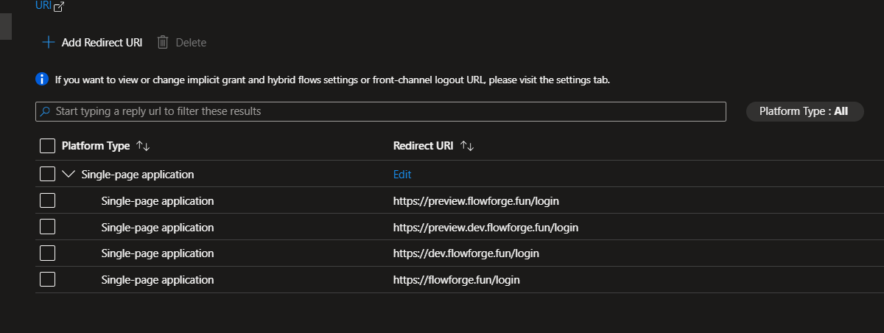

- Now open the App in the App Registrations section and note down the Application (Client) ID and add it as ENTRA_CLIENT_ID in github secrets

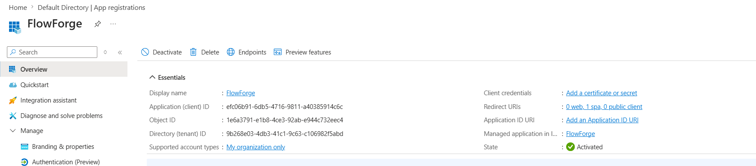

- In the app registration go the Certificates and secrets section and create a New Client Secret and add these values
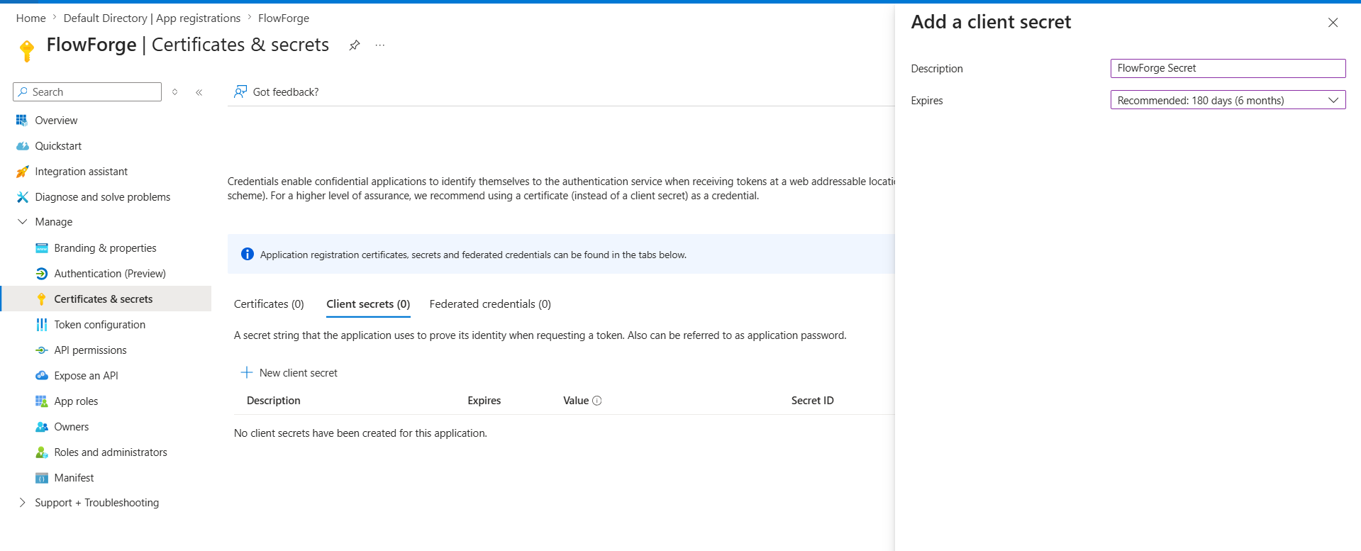

- Copy the Value of that Client Secret and add I as ENTRA_CLIENT_SECRET in Github secrets
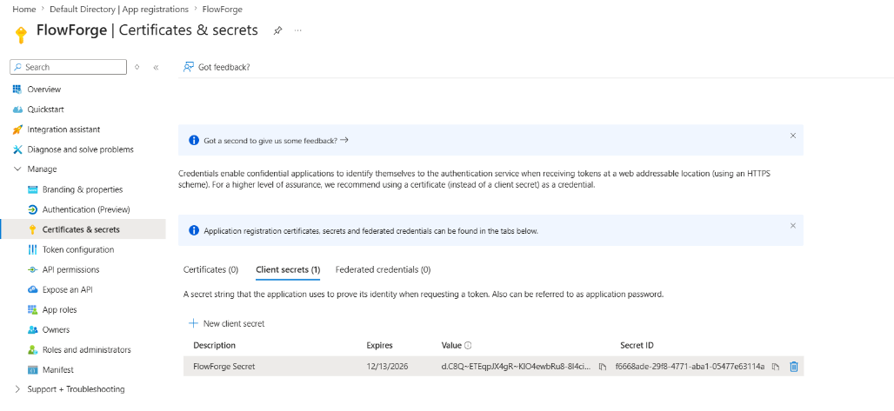

- Now go to Federated Credent
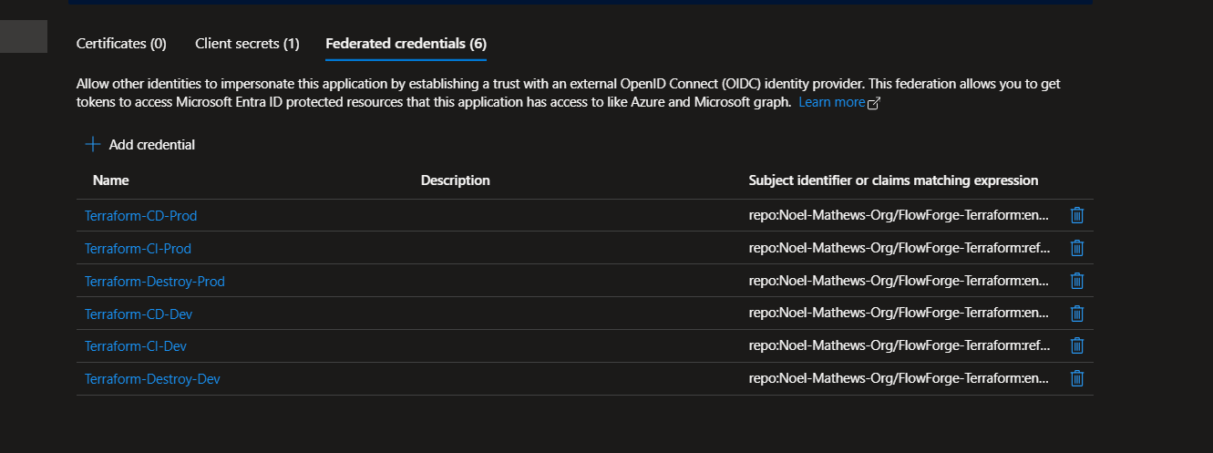

- Now create 6 Federated Credentails
  - Pointing to the prod environment in the terraform github repo
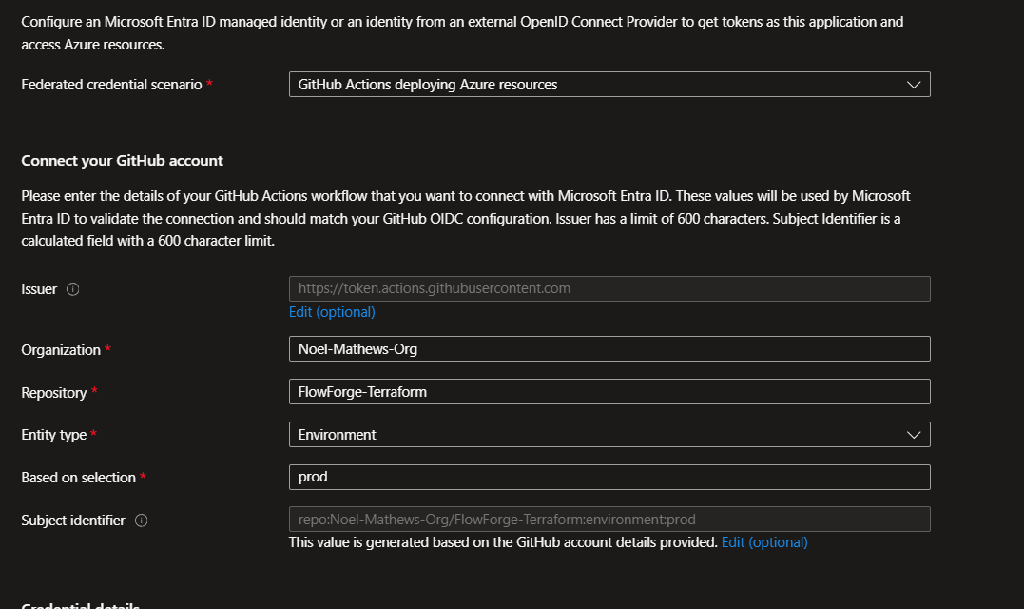

  - Pointing to the main branch of the terraform repo

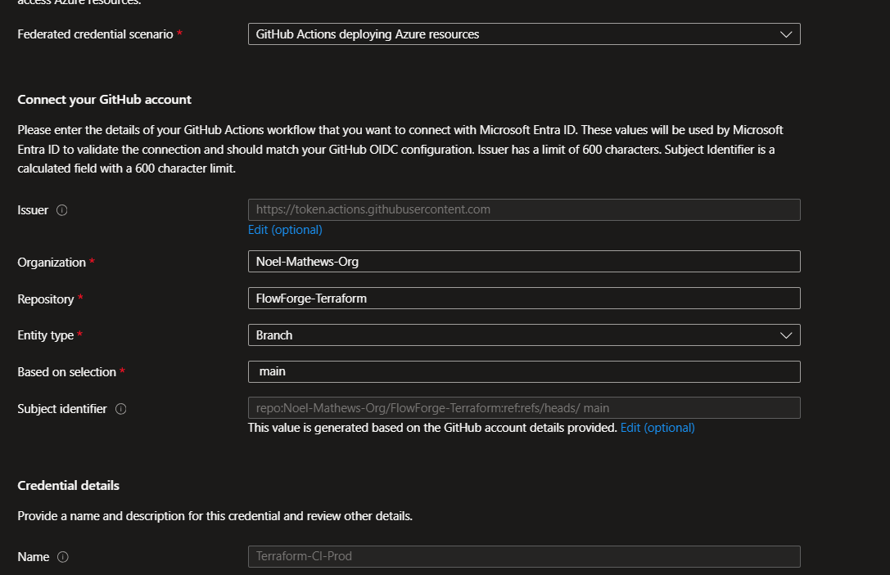

  - Pointing to the prod-destroy env of the terraform github repo
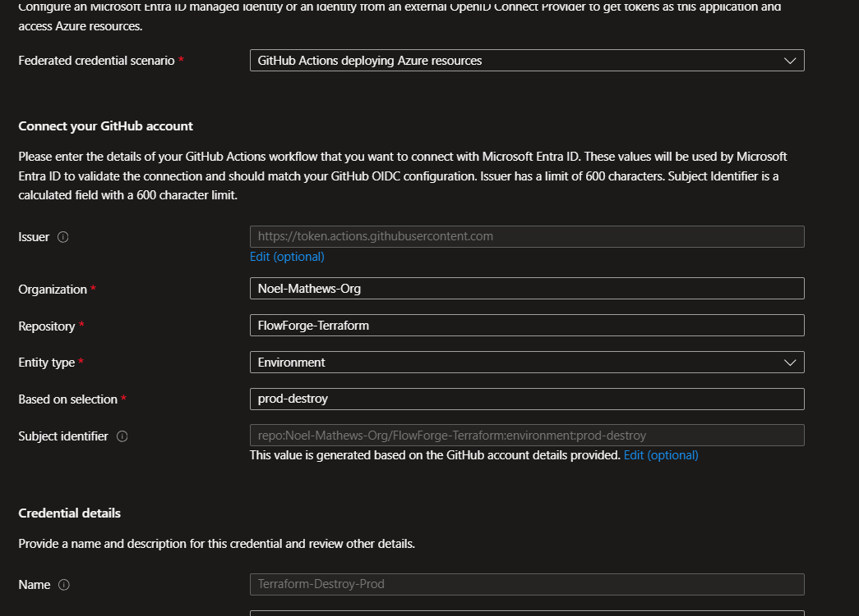

Do the same for the Dev branch , Dev environment , and dev-destory environment

- Go to Token configuration in the app registration and click add Groups Claim

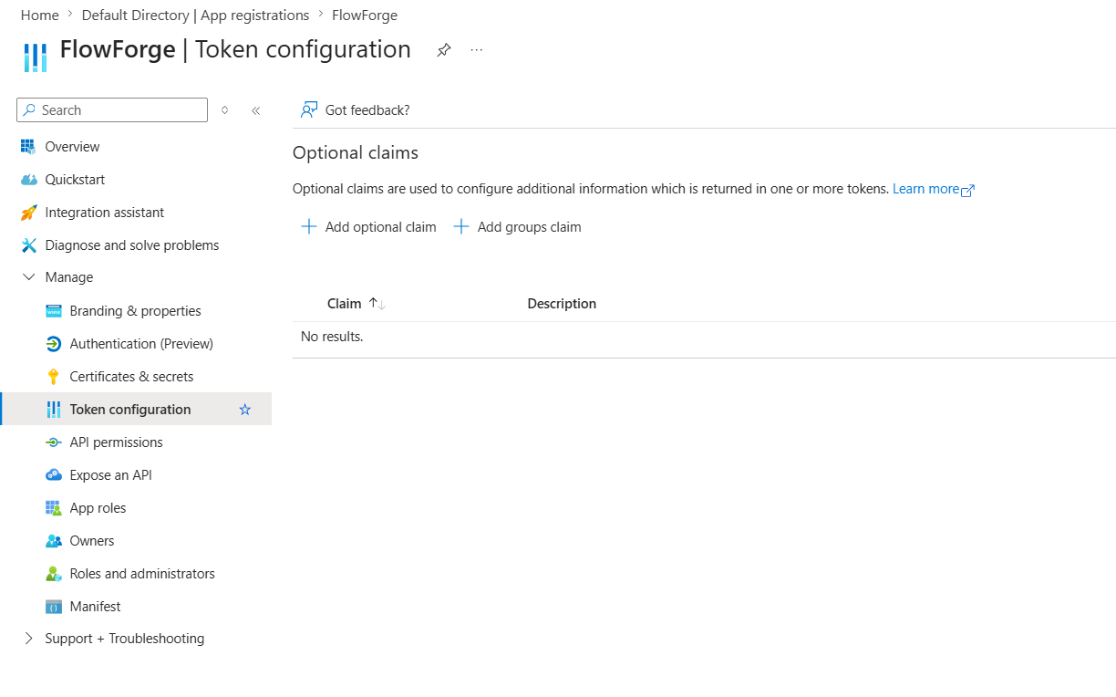

- And then configure these values for it and save it

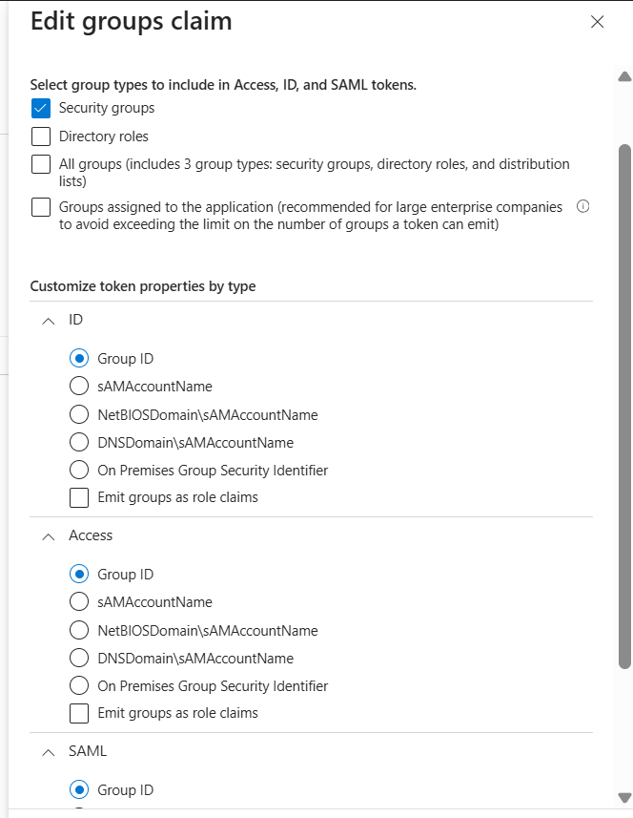

- Now go to API Permissions and click Add Permissions and add these following permissions under the corresponding

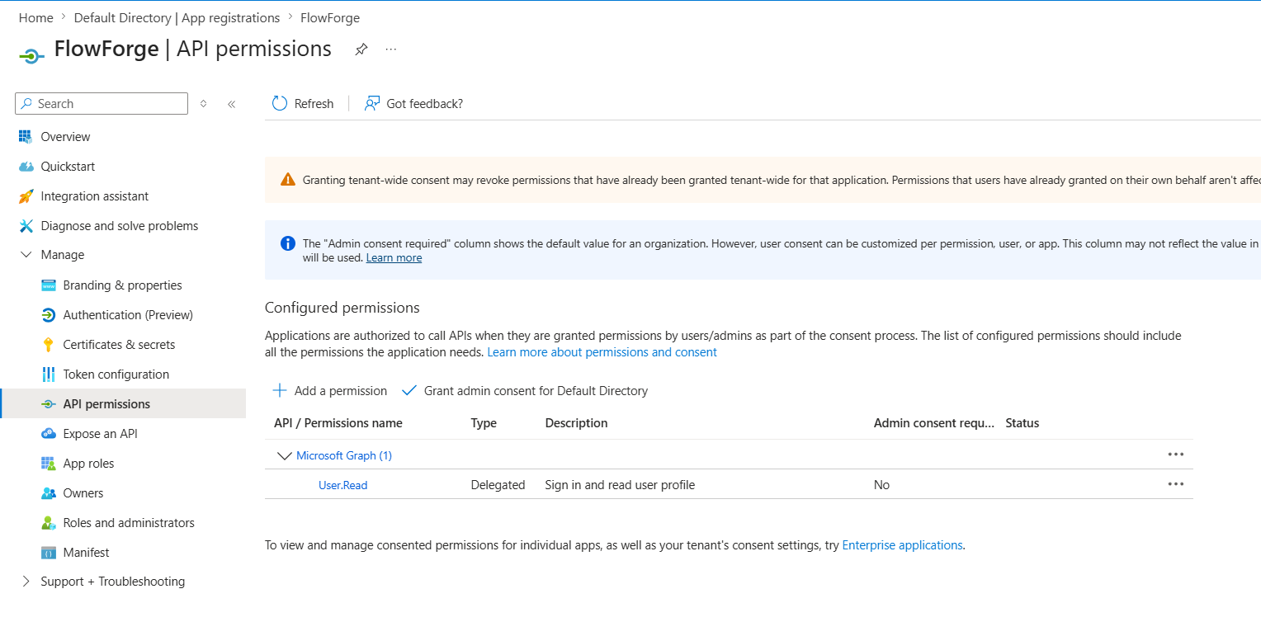

- Click Microsoft Graph

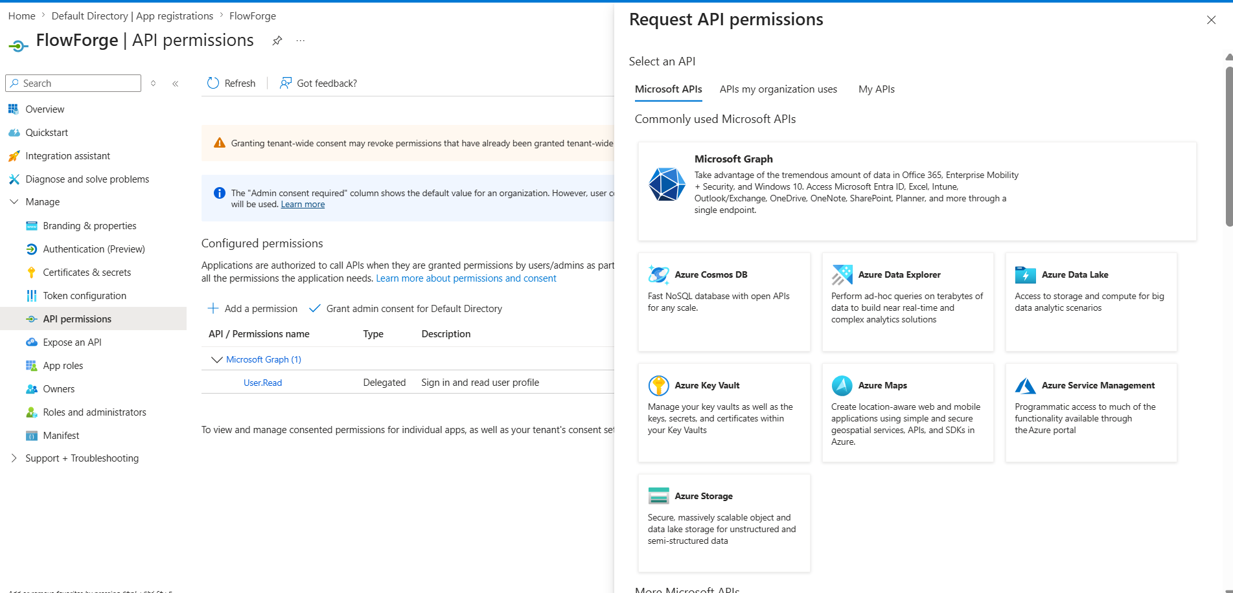

- First set is delegated Permissions

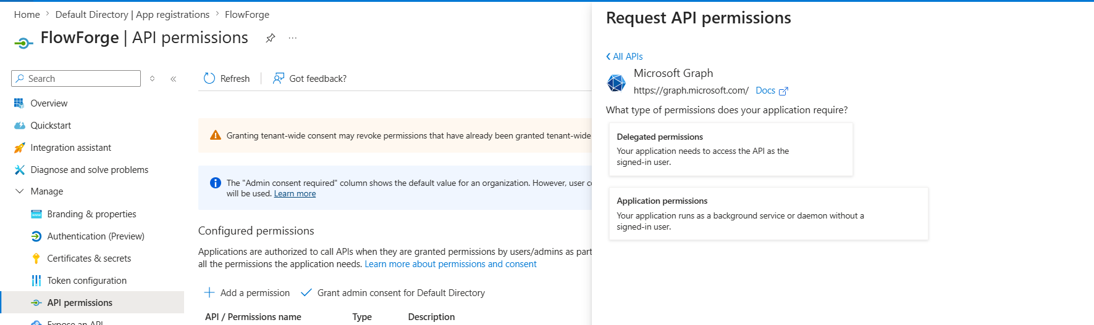
- In delegated Permissions Add these permissions

Group.Read.All
GroupMember.Read.All
offline_access
openid
profile
User.Invite.All
User.Read

- Now go to the Application Permissions



User.Invite.All
GroupMember.ReadWrite.All

- After adding all the permissions click the Grant Admin Consent for default directory

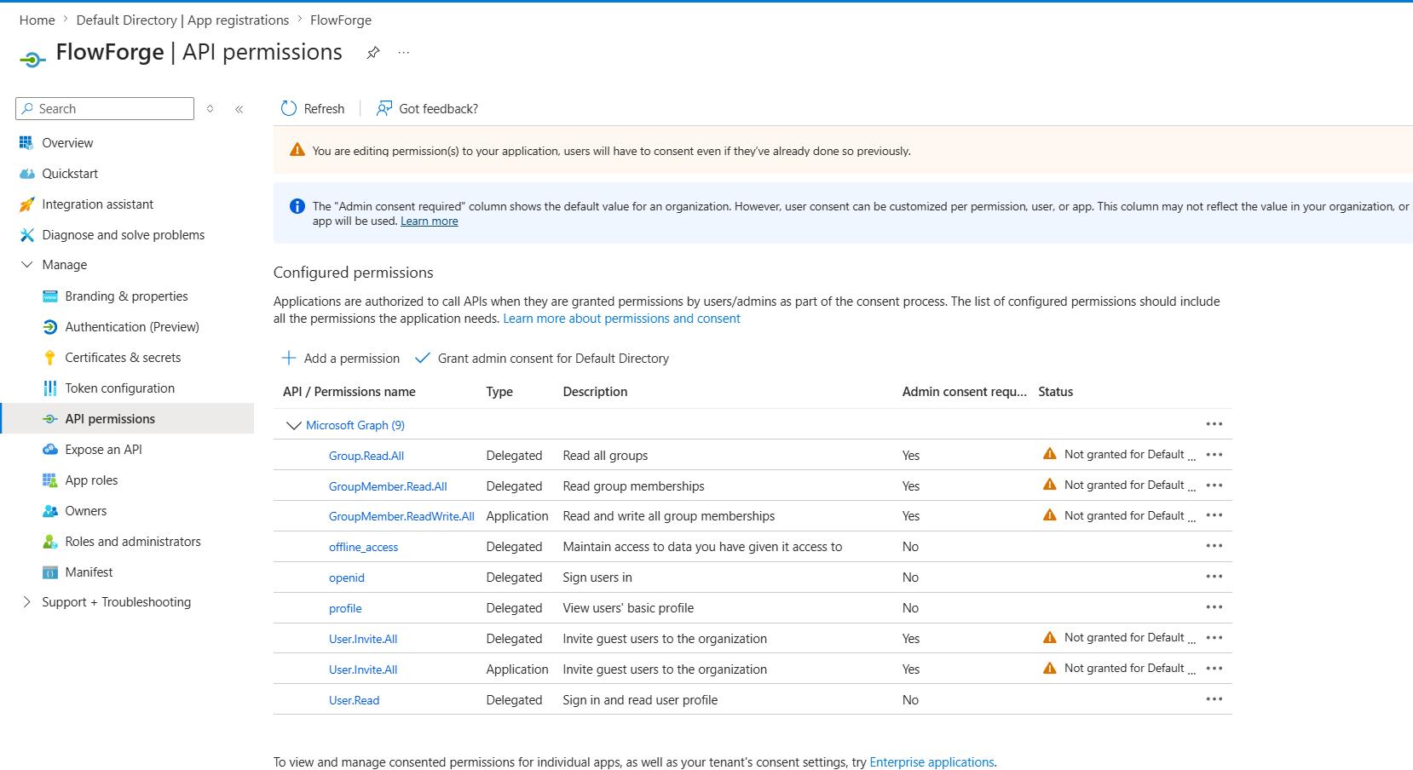

- Now go to Entra ID and note down the tenant id and add it as ENTRA_TENANT_ID in Github Secrets

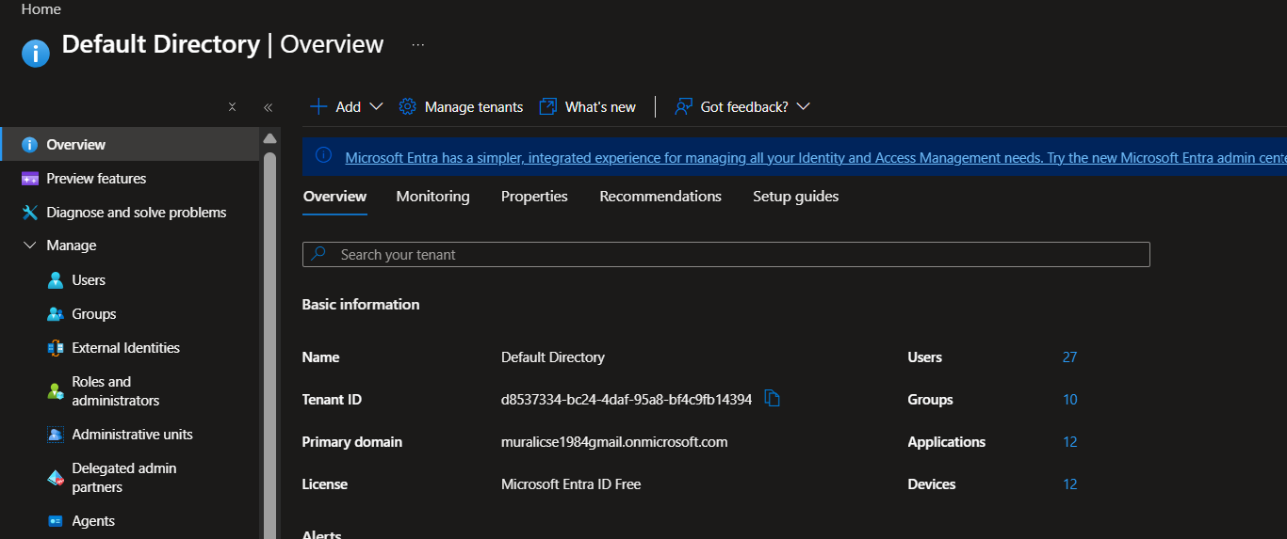

- Then create the following the groups
FlowForge-PlatformAdmin

FlowForge-OrgOwner

FlowForge-Manager

FlowForge-Member

FlowForge-Devops

FlowForge-DevTest

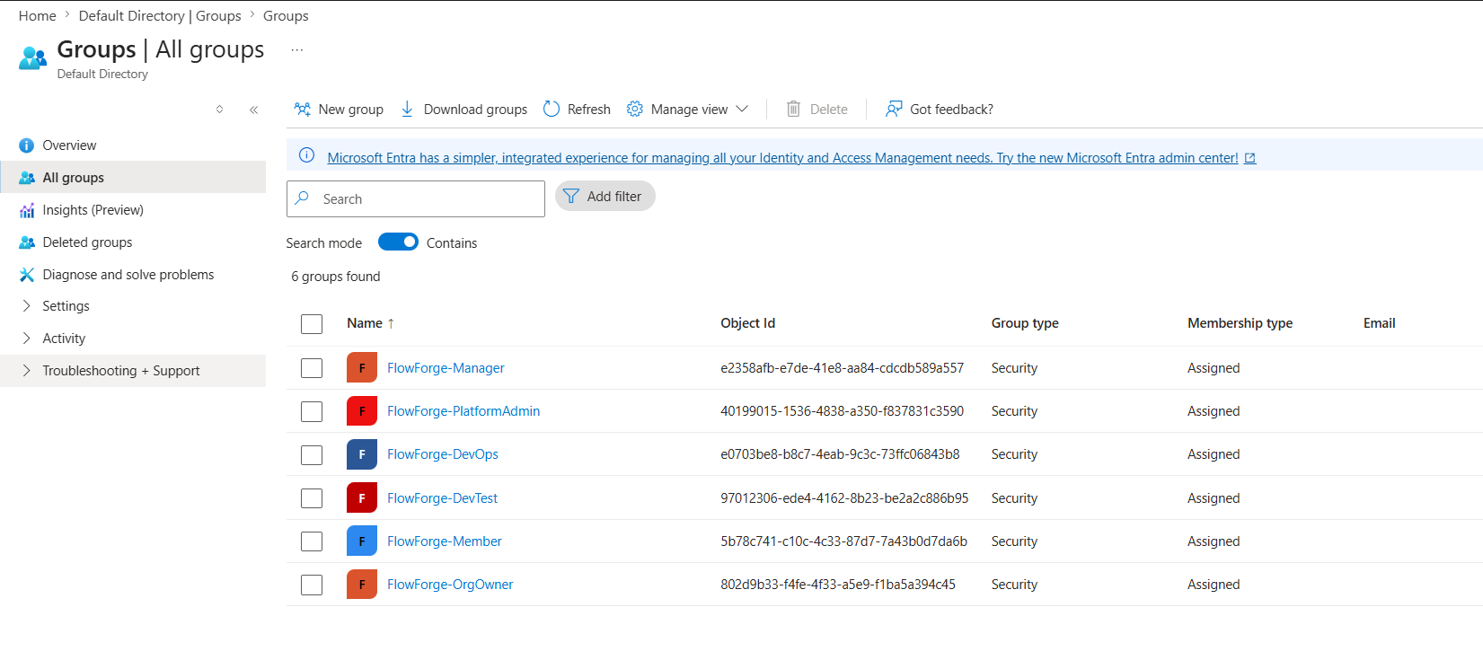
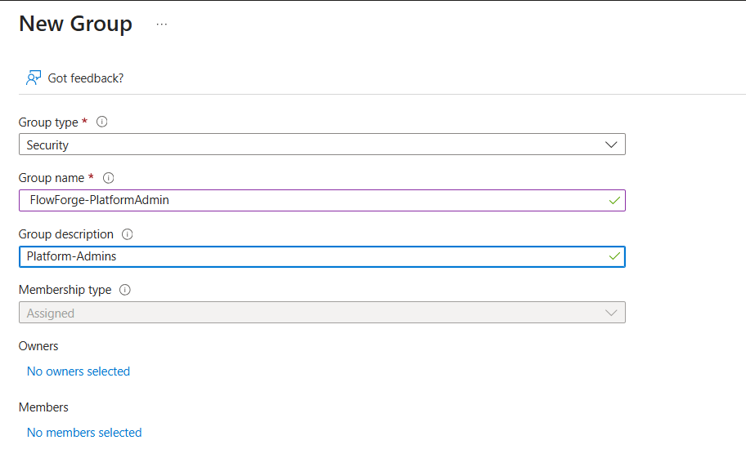
- Same way create the rest of the groups
- Go inside each groups and copy the Object ID mentioned there for 6 groups

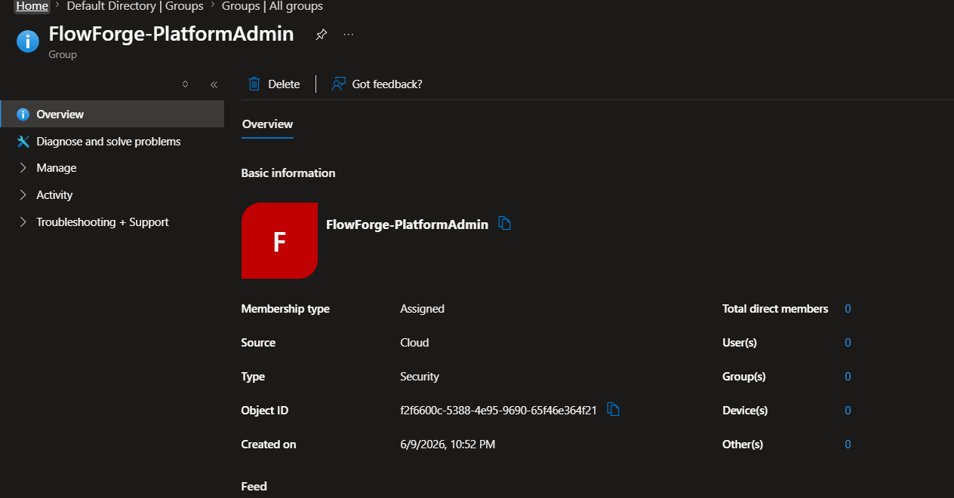

- Store those 4 values in the correspodning values in the Github Secrets in both environments

ENTRA-GROUP-PLATFORM-ADMIN
ENTRA-GROUP-ORG-OWNER
ENTRA-GROUP-MANAGER
ENTRA-GROUP-MEMBER

Add the remaining two groups values in the terraform.tfvars file in the prod or dev environment as you need since it is used to give RBAC permission to the AKS Cluster
devops_group_object_id = " "
devtest_group_object_id = " "
- Now for the next step the user account should have admin privilage to install the Azure VPN App in the App Registration using this link

- https://login.microsoftonline.com/tenant-id/oauth2/authorize?client_id=41b23e61-6c1e-4545-b367-cd054e0ed4b4&response_type=code&redirect_uri=https://portal.azure.com&nonce=1234&prompt=admin_consent

- In this link replace the tenant-id portion with the tenant id you copied earlier and open this url in the browser it will ask your permission to install the azure vpn app inside our tenant

- Select the account or login to the account to which tenant you should install the app or you are planning to run the entire application and give the permission
NB: User should have Cloud Administrator Privilage or Global Administrator
After installing you can see the app in the enterprise app section
Open the app and note down the Application ID
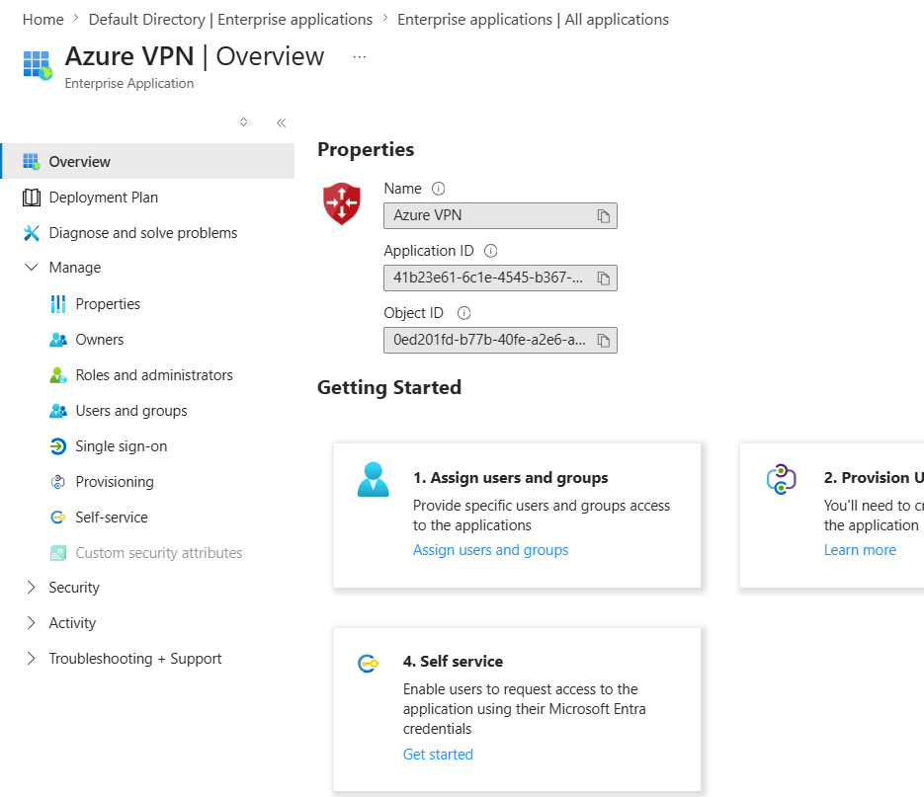
Copy the Application ID and use this value as the value for entra_audience variable in the terraform.tfvars file for the prod env in the folder
- Now go to Entra ID-> Enterprise Application -> FlowForge -> Copy the Object ID

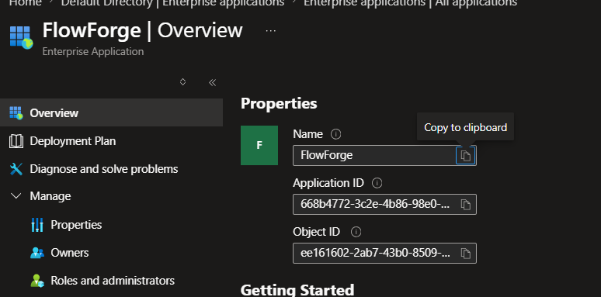

- Now Create a Resource Group named Noel-RG and go to its IAM and Give these roles to the object ID of the App you copied in the above step
  - Contributor – so our IaC pipeline can create resources
  - RBAC Administrator – so our IaC Pipeline can assign roles
- Now go to the Terraform repo and inside it under the scripts folder you will see a file named bootstrap_backend.ps1 , open it and add names for the resource group , location , storage account name , container name and the object id of the app you copied above
NB: Make sure you have logged into your azure account in CLI using az login
This is to create the remote backend to store your statefile safely , and run if it seems good , using ./ bootstrap_backend.ps1 , and you will get the results
Update those values in the provider file of the relevant env
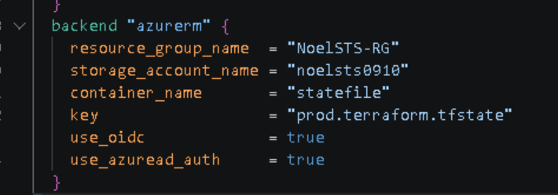
Now you are all set for the IaC Pipeline to run ,

Push everything to the Github and make sure you updated the Github secrets accordingly ,
- If you push to dev branch your dev pipeline will be active which deploy resources mentioned in dev environment in the terraform folder using the secrets available in the dev environment in the repo
- If you push to main branch your prod pipeline will be active which deploy resources mentioned in the prod folder to the prod environment using secrets in the prod environment in the repo
- This pipeline has approval gates to ensure we don’t trigger changes to env unnecessarly , first terraform ci part requires a approval gate and later the terraform cd part requires another approval
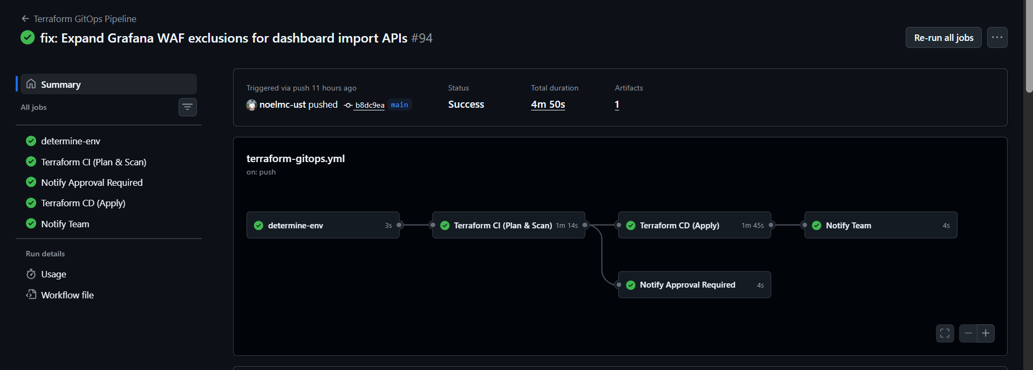
- If you start the pipeline it will take almost 40-60 min to setup the entire infrastructure and this will be the output given by the pipeline

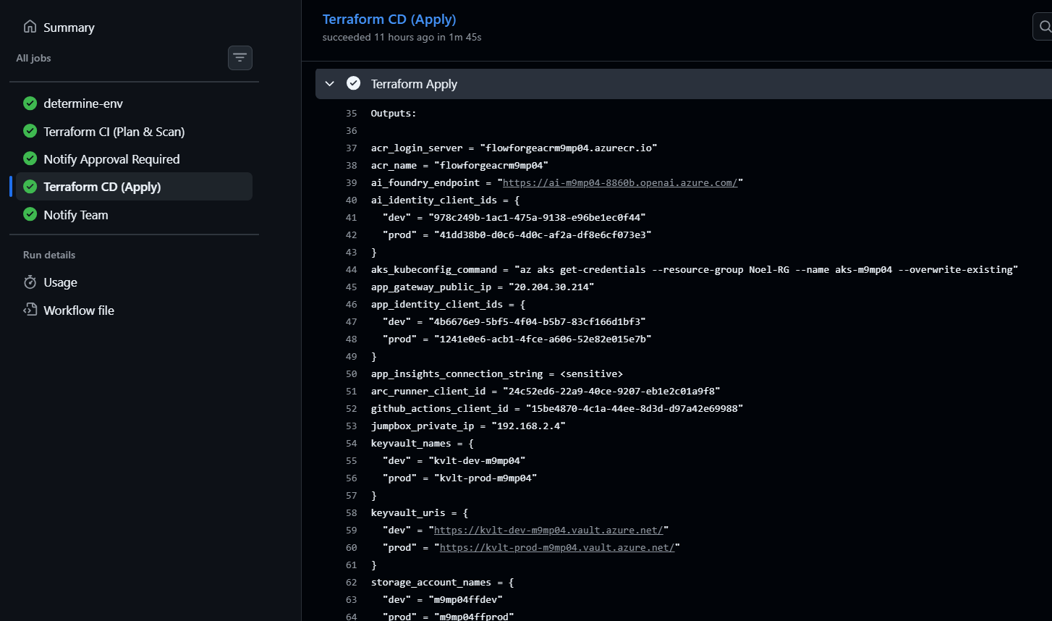
You need to add the application gateway public IP you get from here to your dns providers dns records and create A records for these subdomains

dev
preview
dev.preview
argocd
prometheus
grafana
So we will be able to get the dashboards for these up

After all are setup connect to our AKS Cluster either using the Point to Site Connection we have setup
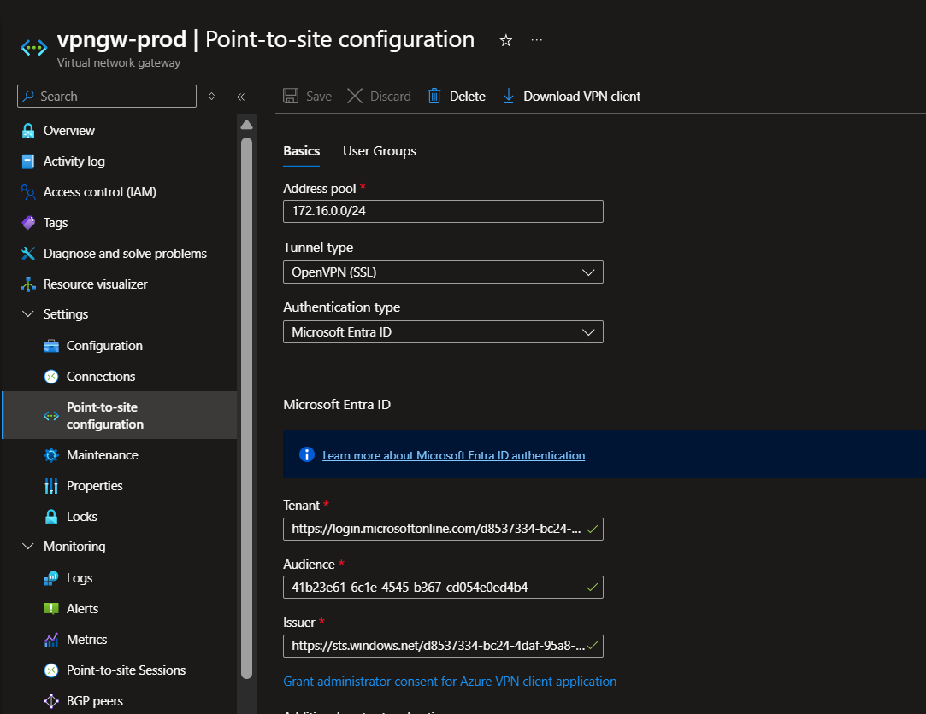

- If you are using vpn gateway , make sure to add your azure account under the FlowForge-Devops group and allowed member under the AZURE VPN App so you can use your entra id to login using the vpn gateway and using your entra id you can access the aks cluster

NB: Only users in the Devops Group have full cluster admin access to ask , the members in Dev/Test group only has read only access to dev namespace (flowforge-dev)
- We have enabled entra id authentication for both AKS and for VPN Gateway using Point to site connection so we can make sure security and governance is correctly followed
- If using P2S , Please download VPN Client form the above shown page and install AZURE VPN Client in your system before accessing and use the downloaded file to import the config into the VPN so you can start your Entra ID Authentication

- Or you can login to the azure portal and login to our jumpbox vm we have setup using the password and username you setup using azure bastion host service

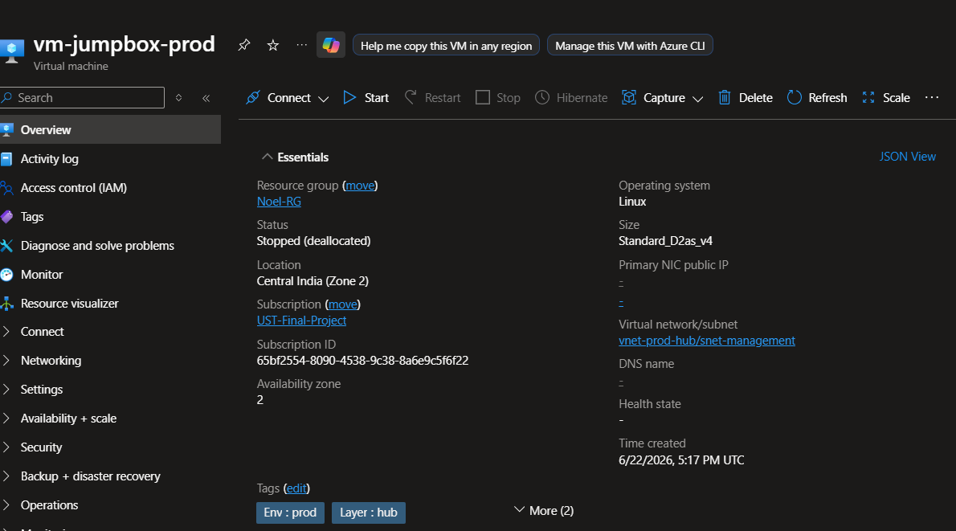

If using the jumpbox please make sure to install azure cli to access our resources so you can login and do any operations ,

After you are connected to the AKS Cluster what we want to do first is , setup the prerequisites for our application and our setup
- We need to install these following in the aks
  - ArgoCD
  - Cert Manager
  - Prometheus and Grafana
  - Argo Rollouts
  - Action Runner Controller
  - Open Telemetry Collector
Now what we have to do is we have node pool one is system and another is called ndoe1
We will taint our system node so we can schedule only our required services there and we can make sure that our resources don’t cause issues to each other
Apply this command so we are tainting all our system nodes
kubectl taint nodes -l agentpool=system CriticalAddonsOnly=true:NoSchedule
If using the Vpn gateway Have the Helm Repo Cloned and setup or if using the jumpbox vm clone these correctly and go into the folder path called infra and there you will see some files
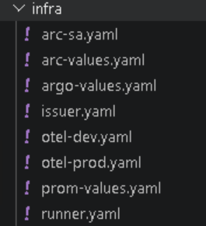
These files are the corresponding values files for installing argocd , promethus and grfana , Action Runner Controller , Open Telemetry Collector , Cert maanger ,
- Argocd , Prometheus and Grafana and our runner pod of ARC have the tolerations required to schedule in the system node pool so that they don’t cram up the resources for our application in the node pool , rest rollouts, cert maanger are all installed in node pool only
First go through those files and change these values:
- in the ingress resources change the domain name to your own domain name
- in the arc-sa.yaml change the client id mentioned there to the client id of the managed identity that we created using IaC for the ARC Runner so we can use those to update the secrets in our keyvault , bc our keyvault is private and has no internet access only through the private network the secrets can be changed, by setting up a self hosted runner inside the aks with a separate managed identity which has keyvault secret officer permission by triggering the pipeline this ARC pod will update the secrest which is our own self hosted runner
- same for the arc-values.yaml change the client id mentioned there to the one described above
- in argo-values.yaml change the domain to your own domain name
- issuer.yaml – update the email to your own
- otel-dev.yaml and otel-prod.yaml – update the client id mentioned there to the client id of the managed identity we created for the Open Telemetry Operator to send the data to our application insights we setup in the Azure which has a permission of Monitoring Metrics Publisher in the Resource Group , which is needed to send the data to the application insights and update the connection string mentioned in both files to the connection string shown in the application insights page in azure
- prom-values.yaml - update the ingress resources in it to your own domain ,
  - in alert manager section
smtp_smarthost: 'smtp.gmail.com:587'
smtp_from: ‘Gmail username’
smtp_auth_username: 'Gmail username’ – update these values to the smtp values you need to send the emails
email_configs:
- to: 'noelmathews123@gmail.com'- change it to the email you need to receive the alerts
- runner.yaml – change to sepc.repository to your repo where you need the self hosted runner preferably the terraform repo since your keyvault update pipeline is there

These are the changes in files needed now you need to create 2 secrest
kubectl create secret generic github-arc-secret \
--namespace arc-system \
--from-literal=github_token="YOUR_PAT_HERE"
Create a Classic Github Token scoped to repo so our ARC runner can access the terraform repo for the key vault update pipeline

kubectl create secret generic alertmanager-secrets -n monitoring \
--from-literal=slack_api_url=’’ \
--from-literal=smtp_password='’
Go to your slack and create a channel and create a incoming webhook for that channel and paste that webhook here and paste your smtp password for gmail (app password) and create the secret
Now lets start the installation process:
- First install the cert manager using this command
kubectl apply -f https://github.com/cert-manager/cert-manager/releases/download/v1.16.1/cert-manager.yaml
kubectl apply -f issuer.yaml

- Wait for some time like 90 seconds and then install argocd
helm install argocd argo/argo-cd --namespace argocd --create-namespace -f argo-values.yaml
wait for some time and then check
kubectl get ingress -n argocd – is it showing your domain correctly

use this command to get the first password of argocd
kubectl -n argocd get secret argocd-initial-admin-secret -o jsonpath="{.data.password}" | base64 -d
if you don’t want to expose it and want to do simple port forwarding for normal usecase use this command
kubectl port-forward svc/argocd-server -n argocd 8080:443
and visit https://localhost:8080

- Now lets install the prometheus and Grafana
  - helm repo add prometheus-community https://prometheus-community.github.io/helm-charts
  - helm repo update
  - helm install prometheus prometheus-community/kube-prometheus-stack \--namespace monitoring --create-namespace \-f prom-values.yaml
Now to get the initial password for grafana
kubectl get secret --namespace monitoring prometheus-grafana -o jsonpath="{.data.admin-password}" | base64 -d ; echo
Please go and check your domains and make sure all are correct , by installing this we have configured promotheus ,grafan and alert manager with some rules and alerting to your slack and gmail.
If you want to see the alert manager Dashboard use this command to portforward it
kubectl port-forward svc/prometheus-kube-prometheus-alertmanager 9093:9093 -n monitoring
and see it in localhost:9093
- Now lets install Action Runner Controller in AKS
  - kubectl create namespace arc-system
  - we have already created the secret
  - helm repo add actions-runner-controller https://actions-runner-controller.github.io/actions-runner-controller
  - helm repo update
  - helm install arc actions-runner-controller/actions-runner-controller \--namespace arc-system \ -f arc-values.yaml
  - kubectl apply -f runner.yaml
  - Now go and check which repo you added in the runner.yaml in the runners section under self hosted runner you should see a new self hosted runner there , you can use that for your key vault updation pipelines
- Now lets install the Open telemetry Operator so we can stream data into the application insights dshbaords
- helm repo add open-telemetry https://open-telemetry.github.io/opentelemetry-helm-charts
- helm repo update
- helm install opentelemetry-operator open-telemetry/opentelemetry-operator \ --namespace opentelemetry-operator-system \--create-namespace
- if you are planning to run both dev and prod then you should apply these both files

kubectl apply -f otel-dev.yaml

kubectl apply -f otel-prod.yaml

or if onely one you are planning then that one is enough

